Hawaiian Lei for your Graduate
(& honored guests)
Beautiful, fresh lei’s come directly from Hawaii
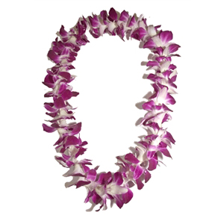
Lei’s may be worn AFTER the graduation ceremony only.
Prepayment required and Orders are due by 5/6/19
$20/each
Order online at www.bellavistagradnite.com
Or turn in payment and order form below to main office by 5/6/19
Cash or checks payable to BV Grad Nite.
Student Name:
Email: Cell Phone:

Quantity | Unit Cost | Total
 | $20.00 each
Total #: | Grand Total | $

Lei’s will arrive on June 5th. All orders must be picked up using Drive-thru pick up on 6/4 in BV Parking lot near the Main Office between 4pm - 6pm.

